Software Requirements Specification

for

Electronic Medical Information System (EMIS)

Prepared by John Callaway

September 25, 2016

Table of Contents

Table of Contents 1

Table of Figures 1

List of Tables 1

1. Introduction 2

1.1 Purpose 2

1.2 Scope 2

1.3 Acronyms, abbreviations, notational conventions 2

1.4 Overview 2

1.5 References 2

3. Specific Requirements 3

3.1 Functional Requirements 3

3.1.1 Use Case Diagrams and Description 3

3.1.2 Class Diagrams and descriptions 13

Table of Figures

Figure 1: Use Case Diagram 4

Figure 2: Class Diagram 16

List of Tables

Table 1: UC - Login 5

Table 2: UC – Edit Personal Information 5

Table 3: UC – Edit Insurance Information 6

Table 4: UC - Add Medical History 6

Table 5: UC - Schedule Appointment 7

Table 6: UC - Send Appointment Reminder 8

Table 7: UC - View Medical Record 8

Table 8: UC - Add Medical Condition 9

Table 9: UC - Update Medical Record 9

Table 10: UC - Order Prescription 10

Table 11: UC - Order Lab 10

Table 12: UC - Add Diagnosis 11

Table 13: UC - Fill Prescription 11

Table 14: UC - Add Lab Results 12

Table 15: UC - Billing Application 12

Table 16: UC - Pay Patient Bill 13

Table 17: UC - View Treatment Receipt 14

Table 18: UC - Pay Insurance Bill 14

# Introduction

## Purpose

This Software Requirements Specification document has been created in order to guide the software development team in creation of the Electronic Medical Information System (EMIS) and allow stakeholders to view the design aspects. It describes in detail who will be able to use the system and the functionality of what can be performed by each user.

## Scope

The software being created is called the Electronic Medical Information System(EMIS). It will provide patients, doctors, nurses, clinical staff, insurance agencies, pharmacies, and lab facilities a way to communicate with greater efficiency and security than current paper methods. A patients medical history and current care will all be consolidated to a single system that allows selected access to view what each party member requires. It will not replace physical visits between a patient and doctor. The EMIS will allow documentation of all sorts, including scanned images, audio recordings, prescriptions, lab orders, vital readings, diagnosis’, and medical history to be accessed remotely.

## Acronyms, abbreviations, notational conventions

## Overview

*The rest of this document contains the functional requirements for the EMIS. It contains a Use Case Diagram with a description and detailed table description for each identified use case. There is also a Class Diagram and description for how the different facets of the software will interact within the system.*

## References

IEEE Computer Society. Software Engineering Standards Committee, and IEEE-SA Standards Board. "IEEE Recommended Practice for Software Requirements Specifications." Institute of Electrical and Electronics Engineers, 1998.

# Specific Requirements

## Functional Requirements

### Use Case Diagrams and Description

Figure 1 shows the Use Case Diagram for the EMIS system. The first use case, UC-01: Login, is connected to every other use case through the <<includes>> relationship. All actors must first succesfully login before performing any other actions within the system. Our diagram also shows that the Clinical Staff is a child of the Patient actor, as well as the Doctor is a child of the Nurse actor. Both the Clinical Staff and Doctor actors are able to perform any of the actions of their parents in addition to their own individual options. The “AddLabResults”, “AddDiagnosis”, and “AddMedicalCondition” are connected to “UpdateMedicalRecord” via the <<includes>> relationship as well because it must be updated each time they are submitted. This also happens with the “BillingApplication” and <<includes>> relationship between “PayPatientBill”, and “PayInsuranceBill”. Using the Time actor, the “SendAppointReminder” can be actived as an extension of the “ScheduleAppointment” use case.

Figure 1: Use Case Diagram

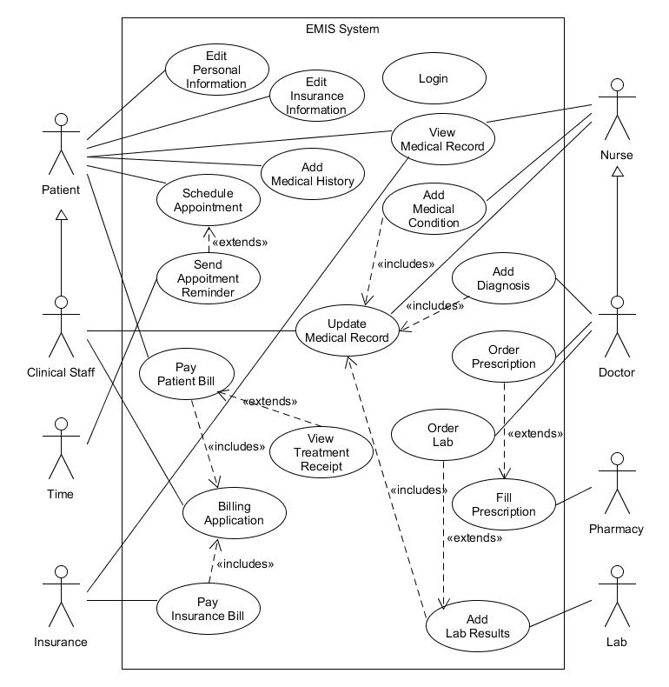

Table 1: UC - Login

|  |
| --- |
| Use Case: *Login* |
| ID: UC-01 |
| Brief Description:  The user enters his login and password information. |
| Primary Actors:  Patient, Clinical Staff, Nurse, Doctor, Insurance, Pharmacy, Lab |
| Secondary Actors:  Time |
| Pre-conditions:  User has a valid username and password. |
| Main Flow:   1. The user enters their username.    1. User forgot username    2. User does not have a username 2. The user enters their password.    1. User forgot password    2. User does not have a password 3. The system allows the user access.    1. The system tells the customer login failed and gives username/password recovery options. |
| Post-conditions:  User has logged into the system successfully |
| Alternative Flows:  None |

Table 2: UC – Edit Personal Information

|  |
| --- |
| Use Case: *Edit Personal Information* |
| ID: UC-02 |
| Brief Description:  The user is able to update their personal contact information. |
| Primary Actors:  Patient |
| Secondary Actors:  Clinical Staff |
| Pre-conditions:  The user must have successfully logged into the system. |
| Main Flow:   1. The use case starts when the patient selects “Edit personal information”. 2. The patient enters their address, phone number, email address, emergency contacts, date of birth, and social security number. 3. The patient selects “Save personal information”. 4. The system updates the patient’s personal information. |
| Post-conditions:  The database is updated with new information. |
| Alternative Flows:  None |

Table 3: UC – Edit Insurance Information

|  |
| --- |
| Use Case: *Edit Insurance Information* |
| ID: UC-03 |
| Brief Description:  The user is able to update their insurance information. |
| Primary Actors:  Patient |
| Secondary Actors:  Clinical Staff |
| Pre-conditions:  The user must have successfully logged into the system. |
| Main Flow:   1. The use case starts when the patient selects “Edit insurance information”. 2. The patient enters their insurance carrier, policy number, group number, and policy holder information. 3. The patient selects “Save insurance information”. 4. The system updates the patient’s insurance information. |
| Post-conditions:  The database is updated with the new information. |
| Alternative Flows:  None |

Table 4: UC - Add Medical History

|  |
| --- |
| Use Case: *Add Medical History* |
| ID: UC-04 |
| Brief Description:  Allows user to enter patient medical information that occurred prior to the current date. |
| Primary Actors:  Patient |
| Secondary Actors:  Clinical Staff |
| Pre-conditions:  The user must have successfully logged into the system. |
| Main Flow:   1. The use case starts when the patient selects “Edit Medical History”. 2. The patient enters past medical diagnoses, past surgeries, medications they are currently taking, and vaccine history. 3. The patient selects “Save medical history”. 4. The system updates the patient’s medical history. |
| Post-conditions:  The database is updated with the new information. |
| Alternative Flows:  None |

Table 5: UC - Schedule Appointment

|  |
| --- |
| Use Case: *Schedule Appointment* |
| ID: UC-05 |
| Brief Description:  Allows user to request an appointment with their doctor. |
| Primary Actors:  Patients |
| Secondary Actors:  Clinical Staff |
| Pre-conditions:  The user must have successfully logged into the system. |
| Main Flow:   1. The use case starts when the patient selects “Schedule appointment”. 2. The system checks for available appointment times. 3. The patient selects an available appointment time. 4. The patient enters their name and the reason for the visit. 5. The patient selects “Schedule my appointment”. 6. The system updates the appointment schedule. 7. The system notifies the clinical staff that a new appointment has been scheduled. |
| Post-conditions:  A message is sent to the clinical staff to schedule the appointment. |
| Alternative Flows:  None |

Table 6: UC - Send Appointment Reminder

|  |
| --- |
| Use Case: *Send Appointment Reminder* |
| ID: UC-06 |
| Brief Description:  An appointment reminder message is sent to the patients email address. |
| Primary Actors:  Time |
| Secondary Actors:  None |
| Pre-conditions:  Must be between 24-48 hours before scheduled appointment. |
| Main Flow:   1. The system identifies the patients who have a scheduled appointment in 24-48hrs. 2. The system identifies the email address for those patients. 3. The system generates an email template for each appointment. 4. The system sends the message to the email address listed in the medical record. |
| Post-conditions:  An email is sent to the patient to remind them about their scheduled appointment. |
| Alternative Flows:  None |

Table 7: UC - View Medical Record

|  |
| --- |
| Use Case: *View Medical Record* |
| ID: UC-07 |
| Brief Description:  Allows a user to view patient medical records |
| Primary Actors:  Patient |
| Secondary Actors:  Clinical Staff, Nurse, Doctor |
| Pre-conditions:  The user must have successfully logged into the system. |
| Main Flow:   1. The use case starts when the patient selects “View medical record”. 2. The patient views their personal information, insurance information, medical history, active medical diagnoses, current list of medications and test results. |
| Post-conditions:  None |
| Alternative Flows:  None |

Table 8: UC - Add Medical Condition

|  |
| --- |
| Use Case: *Add Medical Condition* |
| ID: UC-08 |
| Brief Description:  Allows user to add medical conditions for a patient. |
| Primary Actors:  Nurse |
| Secondary Actors:  None |
| Pre-conditions:  The user must have successfully logged into the system. |
| Main Flow:   1. The use case starts when the nurse selects “Enter patient medical conditions”. 2. The nurse enters the patient’s vital signs, height, weight, chief complaint, new or changed symptoms, allergies, and new or changed medications. 3. The nurse selects “Save”. 4. The system updates the patient’s medical record. |
| Post-conditions:  The database and medical record will be updated with the patient’s medical condition. |
| Alternative Flows:  None |

Table 9: UC - Update Medical Record

|  |
| --- |
| Use Case: *Update Medical Record* |
| ID: UC-09 |
| Brief Description:  The user updates a medical record. |
| Primary Actors:  Clinical Staff, Nurse |
| Secondary Actors:  Doctor |
| Pre-conditions:  The user must have successfully logged into the system. |
| Main Flow:   1. The use case starts when the clinical staff or nurse selects “Update Medical Record”. 2. The clinical staff or nurse selects the type of information to update. 3. The clinical staff or nurse enters the proper information. 4. The clinical staff or nurse selects “Save”. |
| Post-conditions:  The database and medical record are updated with new information. |
| Alternative Flows:  None |

Table 10: UC - Order Prescription

|  |
| --- |
| Use Case: *Order Prescription* |
| ID: UC-10 |
| Brief Description:  A user enters a request for a patient’s prescription. |
| Primary Actors:  Doctors |
| Secondary Actors:  None |
| Pre-conditions:  The user must have successfully logged into the system. |
| Main Flow:   1. The use case starts when the doctor selects “Order Prescription”. 2. The doctor enters the prescription information to be ordered. 3. The doctors selects “Submit Prescription”. |
| Post-conditions:  A request is sent for the prescription to be filled. |
| Alternative Flows:  None |

Table 11: UC - Order Lab

|  |
| --- |
| Use Case: *Order Lab* |
| ID: UC-11 |
| Brief Description:  A user enters a request for a patient to have lab work done. |
| Primary Actors:  Doctor |
| Secondary Actors:  None |
| Pre-conditions:  The user must have successfully logged into the system. |
| Main Flow:   1. The use case starts when the doctor selects “Order Lab”. 2. The doctor enters the procedure name, due date, and optional special requirements. 3. The doctor selects “Submit Lab Order”. |
| Post-conditions:  A request is sent for the lab work to be done. |
| Alternative Flows:  None |

Table 12: UC - Add Diagnosis

|  |
| --- |
| Use Case: *Add Diagnosis* |
| ID: UC-12 |
| Brief Description:  A user enters a diagnosis code for the patient’s ailment. |
| Primary Actors:  Doctor |
| Secondary Actors:  None |
| Pre-conditions:  The user must have successfully logged into the system. |
| Main Flow:   1. The use case starts when the doctor selects “Add Diagnosis”. 2. The doctor enters the diagnosis code, description, and date of service. 3. The doctor selects “Save”. |
| Post-conditions:  The database and medical record are updated with diagnosis codes. |
| Alternative Flows:  None |

Table 13: UC - Fill Prescription

|  |
| --- |
| Use Case: *Fill Prescription* |
| ID: UC-13 |
| Brief Description:  The user updates the system to show that the prescription has been filled. |
| Primary Actors:  Pharmacy |
| Secondary Actors:  None |
| Pre-conditions:  The user must have successfully logged into the system. |
| Main Flow:   1. The use case starts when the Pharmacy selects “Fill Prescription”. 2. The pharmacy selects the option showing the prescription is filled and ready for pickup. 3. If delivery options have been chosen, the prescription will be sent to patients address. 4. The Pharmacy selects “Save”. |
| Post-conditions:  The database and medical record is updated that the prescription has been filled. |
| Alternative Flows:  None |

Table 14: UC - Add Lab Results

|  |
| --- |
| Use Case: *Add Lab Results* |
| ID: UC-14 |
| Brief Description:  The user updates the system with the lab results. |
| Primary Actors:  Lab |
| Secondary Actors:  None |
| Pre-conditions:  The user must have successfully logged into the system. |
| Main Flow:   1. The use case starts when the Lab selects “Add Lab Results”. 2. The lab enters the results of the test and the date of the test. 3. The lab selects “Save”. |
| Post-conditions:  The database and medical record are updated with the lab results. |
| Alternative Flows:  None |

Table 15: UC - Billing Application

|  |
| --- |
| Use Case: *Billing Application* |
| ID: UC-15 |
| Brief Description:  The user accesses the billing application to submit charges to patient and insurance. |
| Primary Actors:  Clinical Staff |
| Secondary Actors:  None |
| Pre-conditions:  The user must have successfully logged into the system.  Billable charges must be pending for the patient. |
| Main Flow:   1. The use case starts when the clinical staff selects “Billing Application”. 2. The clinical staff enters the billable procedures, date of procedures, amount, patient information, and insurance information. 3. The clinical staff selects “Save”. |
| Post-conditions:  A bill is sent to the patient and/or insurance for payment. |
| Alternative Flows:  None |

Table 16: UC - Pay Patient Bill

|  |
| --- |
| Use Case: *Pay Patient Bill* |
| ID: UC-16 |
| Brief Description:  The user submits payment information for pending charges. |
| Primary Actors:  Patient |
| Secondary Actors:  Clinical Staff |
| Pre-conditions:  The user must have successfully logged into the system.  There must be pending patient charges. |
| Main Flow:   1. The use case starts when the patient selects “Pay Patient Bill”. 2. The patient selects payment method. 3. The patient enters their credit card information and amount to pay. 4. The patient selects “Submit Payment”. |
| Post-conditions:  The billing application is updated that the payment has been submitted. |
| Alternative Flows:  None |

Table 17: UC - View Treatment Receipt

|  |
| --- |
| Use Case: *View Treatment Receipt* |
| ID: UC-17 |
| Brief Description:  The user is able to view the receipt for paid treatments. |
| Primary Actors:  Patient |
| Secondary Actors:  None |
| Pre-conditions:  The user must have successfully logged into the system. |
| Main Flow:   1. The use case starts when the patient selects “View Treatment Receipt”. 2. The patient selects which transaction to view. 3. The transaction is shown on the screen and offers the patient an option to download/print. 4. The patient selects “Exit”. |
| Post-conditions:  None |
| Alternative Flows:  None |

Table 18: UC - Pay Insurance Bill

|  |
| --- |
| Use Case: *Pay Insurance Bill* |
| ID: UC-18 |
| Brief Description:  The user updates the system with the lab results. |
| Primary Actors:  Insurance |
| Secondary Actors:  None |
| Pre-conditions:  The user must have successfully logged into the system. |
| Main Flow:   1. The use case starts when the insurance selects “Pay Insurance Bill”. 2. The insurance selects payment method. 3. The insurance enters the payment information and amount to pay. 4. The insurance selects “Submit Payment”. |
| Post-conditions:  The database and billing application are updated with the payment information. |
| Alternative Flows:  None |

### Class Diagrams and descriptions

Figure 2 shows the Class Diagram for the EMIS system. It gives a more detailed description of how the classes and features of the EMIS will interact with each other and the users of the system. All information and interactions are connected to the MedicalChart. It can store multiple medical records, each which contains information from a patient visit. A patient will have multiple medical records as the doctors, nurses, and clinical staff update the system with information about the patient. A medical record will have information relating to vitals, diagnosies, prescriptions, lab results, receipt of treatments performed, and medical history. It can also include any physical documentation or photos scanned into the system as well as audio recordings. The patient, clinical staff, nurse, and doctor will be allowed varying access to the medical chart. Doctors are allowed to submit diagnosis, order tests and prescriptions, but the patient can only view this information after the medical record has been submitted. The pharmacy and lab will have access to both the prescription information, insurance information, and personal information in order to bill the proper parties for their services. Clinical staff and patients can access the message system in order to schedule appointments which are added to the doctor’s calendar. Time will monitor when a patient’s appointment is drawing near and send a reminder through the messaging system to the patient. The billing system allows the clinical staff to bill both the insurance and patient directly. If the patient is covered by insurance, they can submit just the co-pay amount rather than the full billed amount of services rendered.

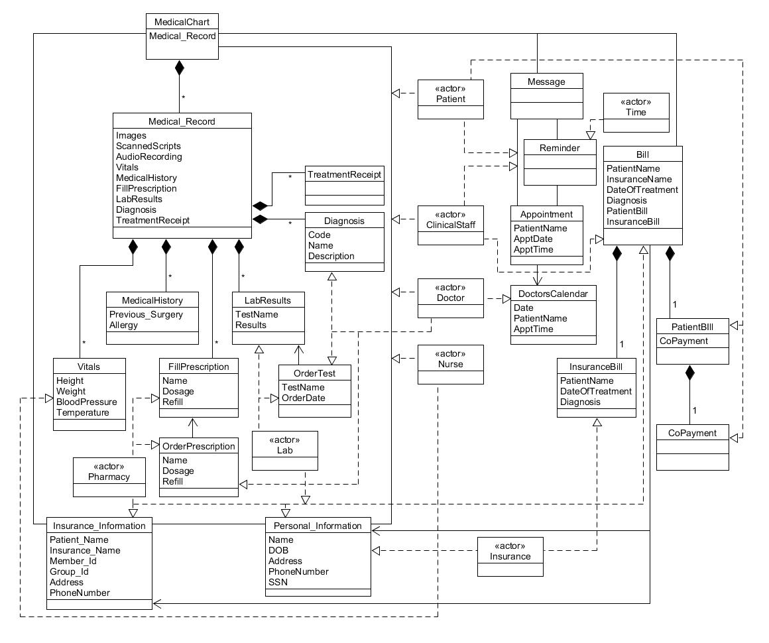

Figure 2: Class Diagram